Specs: These bandpass filters are medium bandwidth HF Filters.
The 3 dB bandwidth is about 150 KHz @ 7 MHz.
The 6 dB bandwidth is about 200 KHz @ 7 MHz.
This BPF Kit is for two (2) bands.. 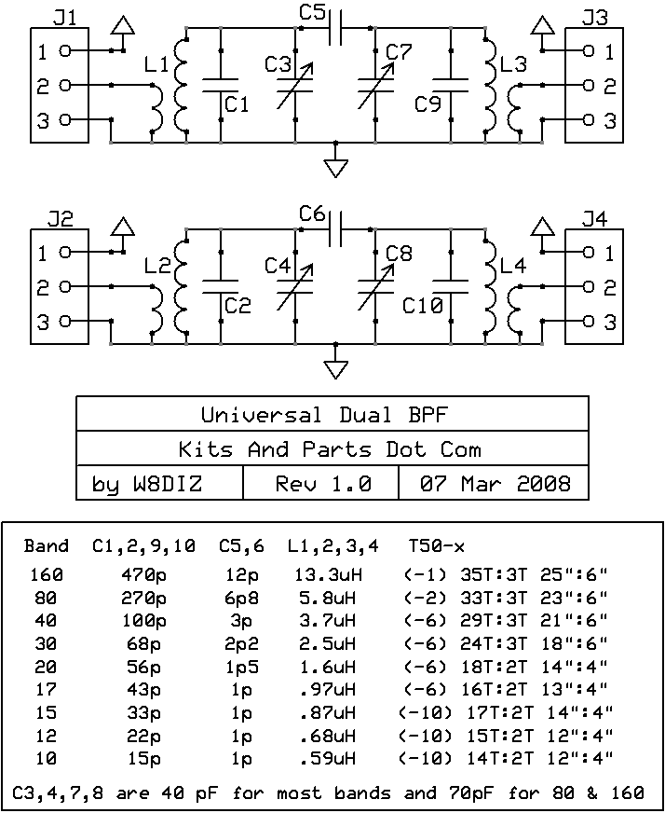
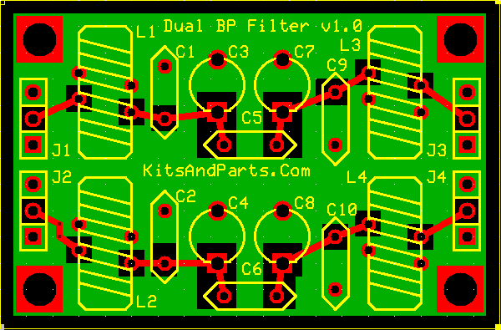
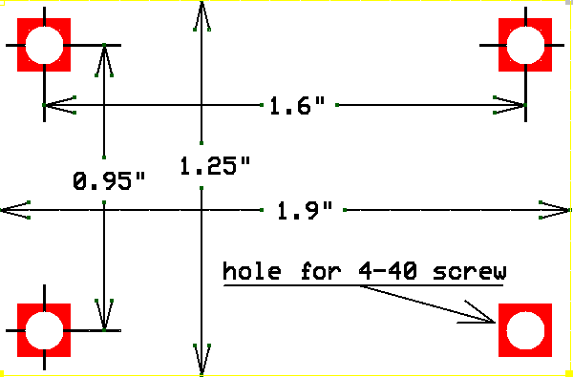
Instructions for one band:
1. Install C3, and C7.
a. Install trimmer capacitors into their correct places per the above PCB layout.
Install with flat side of trimmer into square hole pad.
2. Install L1 and L3.
a. Cut the spool of Copper Colored Magnet wire into 4 pieces per the above table.
You should end up with 2 long pieces and 2 pieces that are 4 or 6 inches long.
b. Wind L1 toroid in a clockwise direction - Toroid Winding Details Here
c. Prepare the toroid wires for soldering - Magnet Wire Soldering Details Here
This magnet wire uses 3 layers of Epoxy insulation and is NOT heat stripable.
d. Install and solder toroid inductor L1.
3. Install L3 just like L1.
a. Review this example of a dual winding toroid for 30 meters.
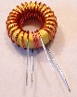 Click picture to enlarge
4. Install C1, and C9.
a. Install capacitors into their correct places per the above table.
5. Install C5 into the correct place per the above table.
6. Connect the BPF via J1 and J3.
7. Repeat for band # 2.

